A

**Report on**

Full Stack Web Development **"Pass The Book"**



Submitted by- Submitted to-

* **Divya kanwar Chundawat Head Of Department,**

**(18EARCS048) Computer Science**

* **Ishika Gupta &IT Department,**

**(18EARCS057 )**

* **Sudhanshu Sharma**

**(18EARCS112)**

**ACEIT, KUKAS**

**Candidate's Declaration**

I hereby declare that the the work which is being presented in the project titled "PASS THE BOOK" in fulfilment of summer industrial training and Submitted to the Dept. of Computer science, **ACEIT(KUKAS)** , is a record of my own investigation carried under guidance of **Mr. Sanjay Rathore , Grras Solutions Jaipur**.

**(Name & Signature of students)**

* Divya kanwar chundawat (18EARCS048)
* Ishika Gupta(18EARCS057)
* Sudhanshu Sharma(18EARCS112)

**ABSTRACT**

Our Project is "Pass The Book". This is a Website where Any reader/Students Can buy and sell the used book very easily. It is useful & Time saving as student/reader can buy/sell books online.

**Pass the book** is an interactive E-commerce Solution providing users with an opportunity to buy and sell used books. It's a online platform which deals with books of every field.

In this Website We have 2 Modules. The First includes customer module & second includes admin module.

**Table Of Contents**

|  |  |  |
| --- | --- | --- |
| **S.No.** | **Topic** | **Page no.** |
| 1. | Introduction | 05 |
| 2. | Tools & Technology | 07 |
| 3. | Application & Description | 09 |
| 4. | Feasibility Analysis | 14 |
| 5. | **Pass the book** -Detailed description | 16 |
| 6. | Conclusion | 22 |

1. **Introduction**

E-commerce (electronic commerce or EC) is the buying and selling of goods and services, or the transmitting of funds or data, over an electronic network, primarily the internet. These business transactions occur either as business-to-business, business-to-consumer, consumer-to-consumer or consumer-to-business.

**Pass the Book** is an interactive E-commerce solution providing users with an opportunity to buy & sell books . We Furnish the needs of the user in terms of learning, education & technology with providing them an online platform where they can easily buy & sell used books on our website.

This project is mainly divided into two main categories: The Administrators and the Customers/Users.

The store manager and the staff members operate as the administrators. They can add, edit, update products or, delete products thus they able to change the names of products, change prices and, add or remove products.

The customer can search for products selection, update the cart, remove products from the cart and check out from the shop. The customer is also able to update his infor-mation such as names, address and other data.

The User is only able to browse the online shop and add a product to the cart. The user is limited to the use of the shop.

**1.1 Objectives**

Online Shopping is the process whereby consumers directly Buy Goods & Services without any intermediatory service.

The same is the Goal of this project/Website (**Pass the book)** to develop a web based interface For the users to buy books, in addition to it, Seller & Consumer Can directly Contact Each other , Which reduces the hesitation of Consumer To buy any book.

**2.Tools & Technologies**

These are the necessary tools and materials needed to build the website both the front-

end and the back-end. These include software and open source materials.

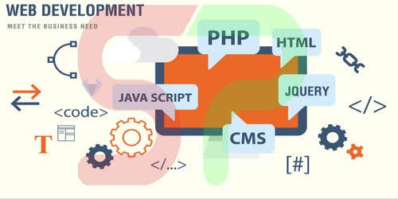

**2.1 HTML**

HTML means Hypertext Markup Language. This language is used in creating web pag-

es. This language also supports other languages such CSS, PHP, JAVASCRIPT, etc. in

creating interactive and responsive pages on the pages.

**2.2 CSS**

CSS is simply referred to as Cascading Style Sheets.CSS is used to define styles for web pages, including the design, layout, and variations in the display for different devices and screen sizes.

**2.3 GITHUB**

Git lets developers see the entire timeline of their changes, decisions, and progression of any project in one place. From the moment they access the history of a project, the developer has all the context they need to understand it and start contributing.

Businesses using Git can break down communication barriers between teams and keep them focused on doing their best work. Plus, Git makes it possible to align experts across a business to collaborate on major projects.

**2.4 Typescript**

Typescript is a high-level language which could be used independently or inculcated into the webpage. It can be used to, handle requests and responses and also add dynamic behavior and also store information on a website.

**2.5 Mangodb**

MongoDB is an open-source document database and leading NoSQL database. MongoDB is written in C++.

Other Technologies used in this are MongoDB, Express, react, Angular.js, Node.js.

**3. Aplication & Description**

**3.1 Overview of Various Parts**

This project has several parts to it, but the most essential are three listed as follows-

|  |  |  |
| --- | --- | --- |
| **Administrators** | **Customer** | **User** |
| Login Acess | Login acess | Cannot login |
| Can add products | Can add to cart | Can add to cart |
| Can edit products | Can edit products in cart | Can edit products in cart |
| Can view product | Can checkout | Cannot Checkout |
| Can delete product | - | **-** |

**Table: The overview of 3 major Parts.**

**3.2 Administrators Detailed Attribute**

➢ Admin register

The administrator needs to register before they can have access to the core data of the

shop.

➢ Admin login

The admin logs in and can view, add products, manage customers.

➢ Admin Edit

The Admin can make changes to the shop such as delete customers, add a customer or,

upload new products.

➢ Manage Customer

The administrator has the authority to delete or add a customer.

**3.3 Customer Detailed Attribute**

➢ sign up

This refers to registering as a customer. The registered member has a lot of privileges

associated with the shop when one becomes a customer.

➢ Login

After the user has registered, the user becomes a customer, and he or she can log in with their personal information.

➢ View

The customer can see all the products in the catalog and able to look at the products and some features on the homepage.

➢ Edit

The customer can make changes to their data displayed on the customer page.

➢ Update Cart

This refers to putting or removing products from ashopping cart.

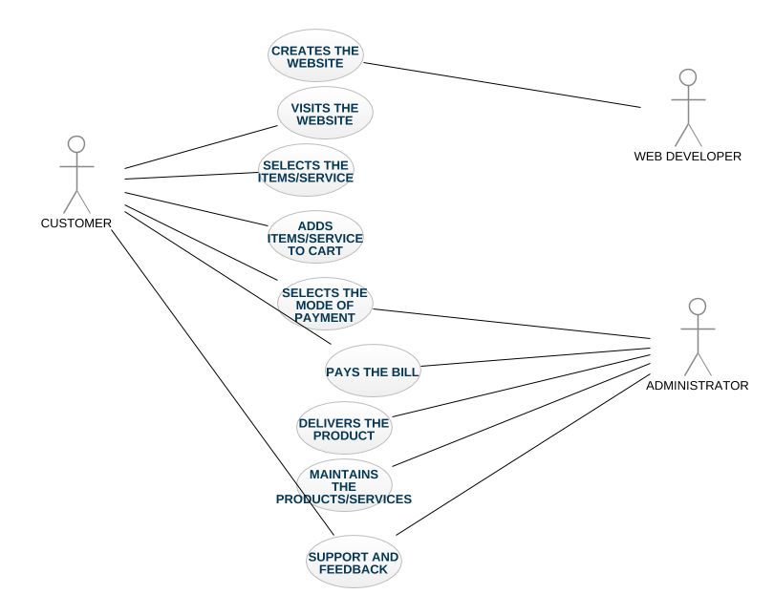

**Fig: Use Case Diagram Of Website**

**3.4 The Various Management Unit**

➢ User registration

The Users will use their exclusive information to register. After filling the form and submitting it, the html5 checks to see if all the fields entered by the user are correct. If the area is not correctly filled the user remains on the same page but if the requirements are met the data goes to the database (table "customers") and saves the information of the User. The User then becomes a customer, and he or she is then directed to the login webpage of the shop.

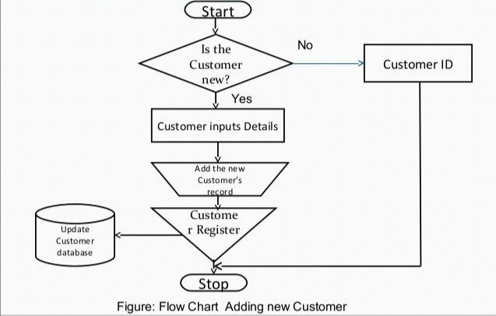

➢ Customer login

The customer will use his particular data e-mail and password to log into the shop. After submitting the form, the html checks if all the fields have been filled correctly. If the condition is not met the customer remains on the same page but if the fields are correct-ly filled the customer login information is sent to the database to check if the data en-tered into the areas are same as the ones used to register to the database. If it is correct,the customer is redirected to his homepage, and he can successfully pick products and check out if they are done shopping.

➢ Administrator Login

When the admin logs into the Administrators webpage the html5 checks to see if condi-tions are met when logging in. If all the information provided are correct, the data is sent to the database to check if the data corresponds to the information used to register.If it matches to the information provided by the Administrator, a page opens, and the admin can have access to the administrator's webpage if not the administrator is restrict-ed from having access to management webpage. The Figure 9 shows the administrator log in diagram.

**4. Feasibility Analysis**

**4.1 Introduction-**

The Main purpose of feasibility study is to test the technical, Operational & Economical Feasibility for adding New Modules & Debugging old running system.

All System are Feasible if there are unlimited resources of infinite time.

Basically , there are 3 Type of Feasibility-

* Technical feasibility
* Operational feasibility
* Economical feasibility

**4.2 Technical Feasibility**

* The Technical feasibility study basically centers on alternatives software, hardware & design approach to determine the fundamental aspects of system.
* This project **Pass the book ,** an online platform to sell/buy books will be platform independent since it is being coded(using typescript & CSS). Html is being used for creating web pages.
* Mangodb Database will be used for storing data.
* Hardware Requirement are compatible for all operating system.
* Technical feasibility is concerned with Specifying Equipment & Software that will meet the equipment and goals.

**4.3 Operational Feasibility**

Operational feasibility is the measure of how people are able to work witb the system. This type of feasibility demand if the system will work when developed & installed.

Some of the important issues raised during operational feasibilty are-

* Will the system be used & Work properly if it is being developed & implemented?
* Is there sufficient support from the management for the user?
* Since our Website is very user friendly ,So users will find it comfortable to work on this site.

**4.4 Economicaly Feasibility**

A system can be developed technically and that will be installed, if it must be a gokd investment for the organization.

Fibancial benefit must equal or exceeds the costs. It is most frequently used evaluating the effectiveness of proposed system, commonly known as benefit analysis.

**5.** "**Pass the Book" -** Detailed Description

* An influencing E-Commerce website, Made to ease the problems Faced Now a days by students/ reader to find book at low cost either used or new.
* Here, In **Pass the book** website, Buyer & Seller can directly contact to each other in this platform to sell/buy books. Keeping in view, To save two very things nowadays in a World Full of Competition i.e. **Time & Effort,** Website is designed perfectly & is user friendly.

**5.1 Customer Interface Layout**

Consumer refers to customers and non-customers. These are individuals who visit the shop either to buy products or to browse. There are two categories of interfaces namely the Consumer and the Administrator interface.

The administrator has higher authority over the customer in the shop. The admin can edit, replace a product/ Book and, manipulate data in the Website. The customer can browse any Book available there add respective book to the cart, change personal information, check shopping history of books and checkout or log out.

The User, on the other hand, can only browse and add a Book to cart.

**5.2 Home Page of "Pass the book"**

The homepage or interface is the index page of the shop/Website so can be accessed when the address is typed into a browser. The webpage has Books images, names, prices, its categories and Book's Publisher Name. The webpage has a registration link, login link, Categories, Publish book Options.

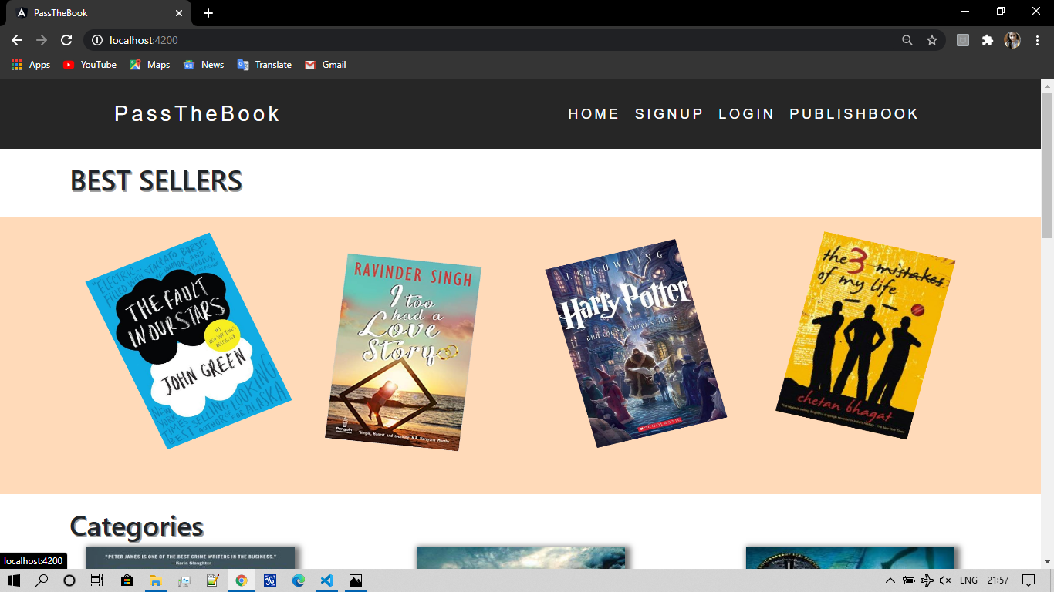

**5.3 Registration Web Page**

This registration page is only for users who wish to become customers. They have to meet the required filled standard for them to register successfully; otherwise, they will remain on the same page. When they register, their information is saved directly to the "customer". This registration file "customer_registration.php" is run with a code editor.

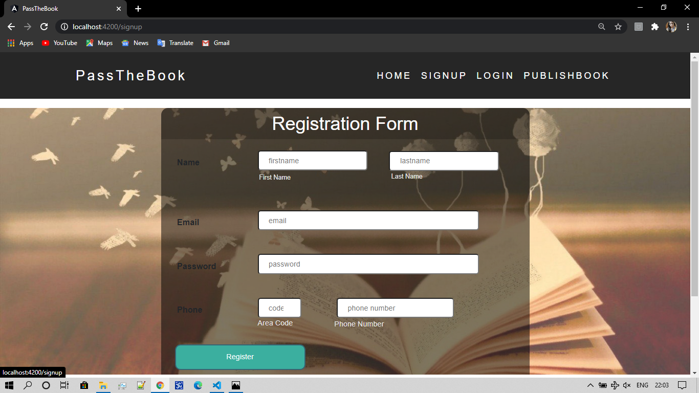

**5.4 Seller Registration web page**

This web page is for the registration of the seller on the website so that they can publish there book along with the photo of its cover. After the book is published on the Website, User/Customer can easily see this info & can access to it.

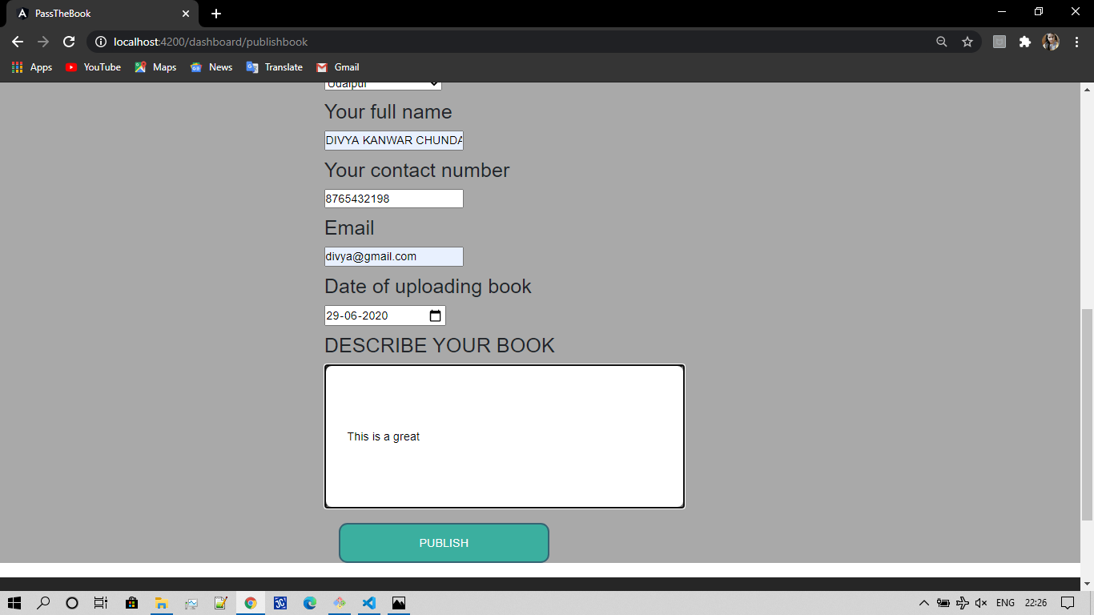

Here, in this web page, Seller can add his/her contact number, email id, & also Date of uploading book. along with all this he/she will have the option to describe his book for better understanding of user , so that user may feel comfort to buy it.

**5.5 Login Web Page For Customer**

Once the user has become Customer by registering to the website, he/she may Login at any instance of time & can easily browse for the book. Once the user sucessfully logged in the account, he/she will be able to see booms along with this the past records of books there.

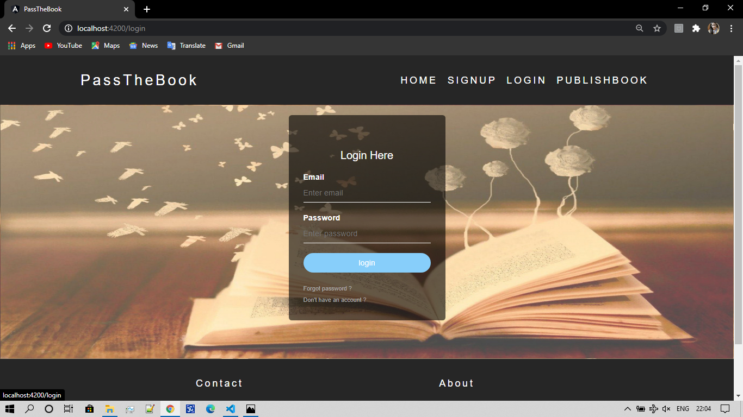

* **Some More Screenshots of website**

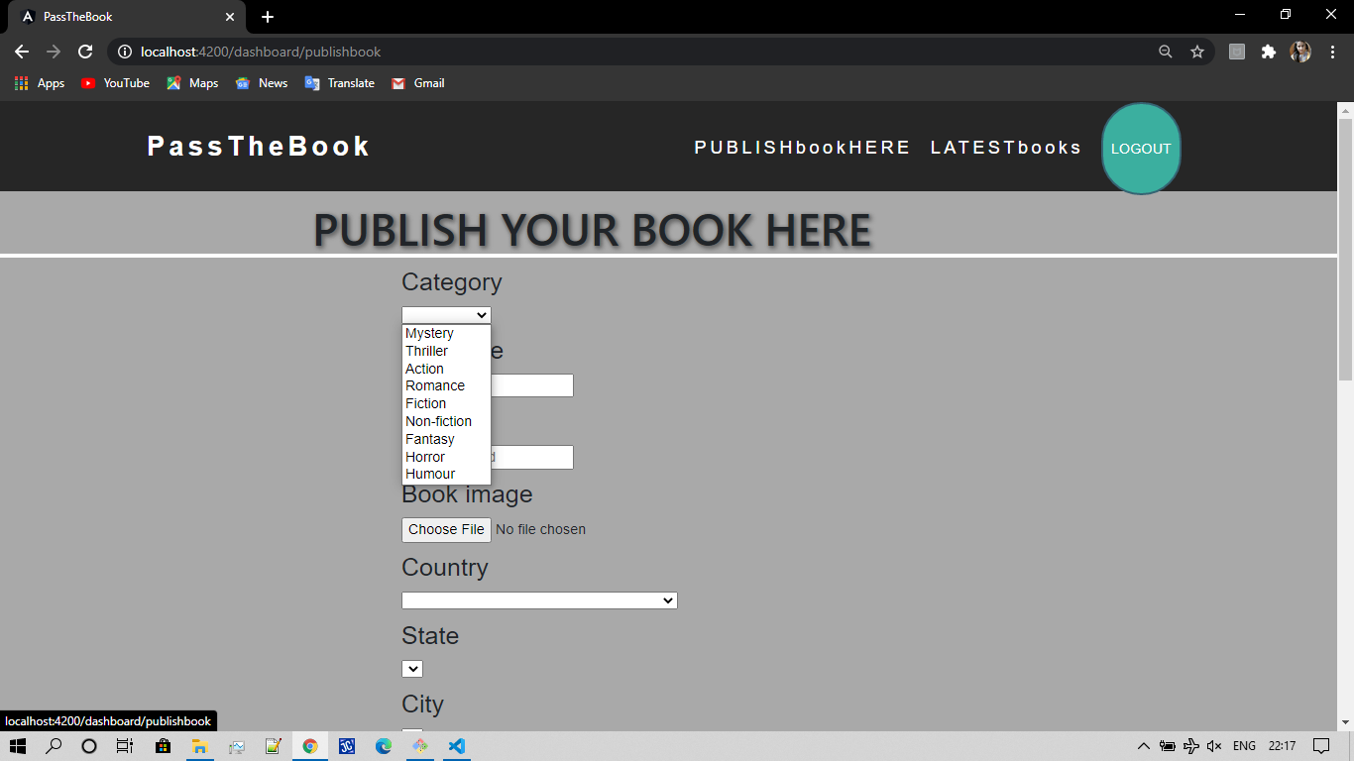

In seller registration webpage, Category Option is cleary in shown in above fig. It has various categories of books available like Mystery, Thriller, Action , Romance, Fiction, Non Fiction, Fantasy ,Horror, Humour. In this way , a ,customer can easily find the book in his/her field of interest & definitely it will save the time.

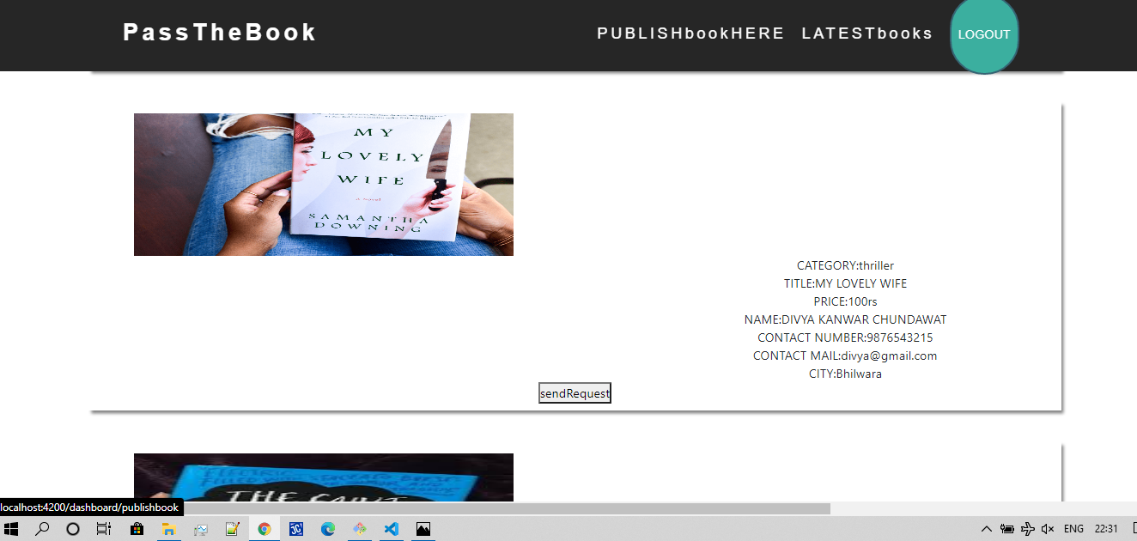

Above fig shows the Contact details of Seller Along with the book. Whenever user find the book , he can accordingly send the request & Can Contact the seller through the given details. In this way , there is a direct connection between Seller & Customer without any other interference.

**6. Conclusion**

The **Pass the book** website was developed using HTML , CSS, Typescript, Mangodb, etc technology. Any consumer can browse books, according to his/her choices mentioned there.The consumer can log in, with his information such as his email and password. If the login does not go through, the user can re-register or ask to change the password. After login, the user can see the books all available there & then Seller can verify the order , Once Consumer contact to him. So in this way Consumer & Seller Can directly contact to each other through this website.